

Children & youth consultation on the new Essex Police
children & young person’s strategy priorities

ECVYS were commissioned to deliver a Youth Voices Project by Essex Police to seek children & young people’s views in Essex, Southend & Thurrock on the Police’s new Children & Youth strategy, focusing specifically on their strategic priorities.
ECVYS facilitated this project around the given priorities and invited groups to take part that would give a fair representation of children & young people’s views from various diverse backgrounds- prioritising groups who often don’t get their voices heard as much as they should.

The project was aimed at young people in voluntary youth settings who are currently engaging
with their groups via Zoom (because of the pandemic), face to face or through detached work. It was run by their own youth leaders, who could run the session plan with any ice breakers included to encourage discussion, fun and honest engagement around the topic.

The priority headings for discussion were-
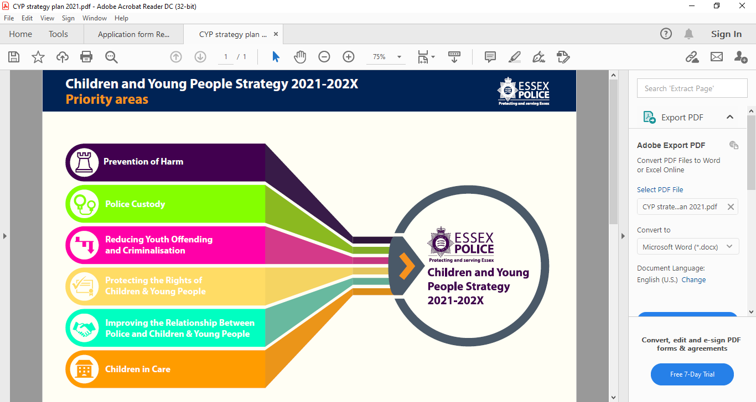

Who took part in the listening project?

15 children’s & young people’s groups took part in the listening project across Essex, Southend & Thurrock. Most of the sessions were completed with groups online, although a couple were done face-face and one session was completed with young people in a detached youth work setting. The sessions were run by the groups own leaders as they are trusted by the young people and it was felt this would lead to a more open and honest conversation. Each group that took part received a £90 donation towards the cost of the staff/ volunteer time, venue or online hosting costs & any resources/ refreshments needed. This donation goes a long way to supporting these groups and recognising the valuable contribution that they have made to the report and the children & young person’s police strategy. Groups will also receive a copy of the final report so that they can discuss the findings and contact us further if they wish.

The children’s & youth groups who took part were-

EmpowerHER (Basildon)  -For girls aged 10-15 years who may lack self-confidence or have low self- esteem  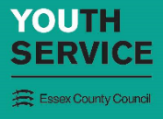  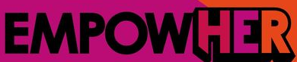 | Enterprise East (Uttlesford)  -Support & training for young people facing barriers & challenges to work)   | Essex Youth offending team (Chelmsford)    -Young people who have experience of the criminal justice system
ECC Children in Care council  -Young people who have been, or are currently in care  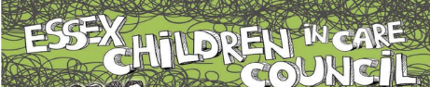 | Girls Empowerment (Thurrock)  -BME Girls group   |   Chelmsford Diocese (Essex wide)  (Young people’s faith & discipleship group
Colchester Korban    -supported housing for 16-25yrs olds | ESSEX YMCA    -Supported housing for 16-25yr olds | Essex Youthbuild  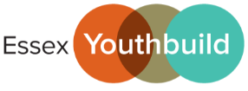  -Providing training in construction & employability skills for young people aged 11-19
The Childrens Society    -Emotional management group | Essex Fire Cadets  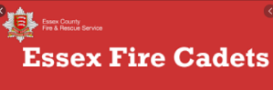  (Various groups from across Essex) | Essex Police Cadets    (Clacton police cadet group)
Gateway (Basildon)  (13-25 SEN young people’s group)  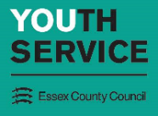 | Southend YMCA  -LBGT+ group   | North Avenue youth centre Melbourne, Chelmsford  -Detached youth work session  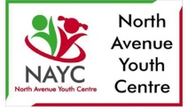

217 children & young people from across Essex, Southend & Thurrock took part in the listening project

Findings from the listening project:
Do children & young people think that 'Prevention of harm'
is a good priority area to have?

96% of children & young people agreed that
‘prevention of harm’ is a good priority

Why is ‘prevention of harm’ a good/ not so good priority to have?
The most popular answers to this question
1 | Because preventing harm is the best thing to do
2 | Because the police will keep us safe
3 | It means they will protect the vulnerable
4 | It means the police will help look after our mental health
5 | The police should do this anyway
6 | It’s good to protect the community
7 | Because I feel safe when see police around
8 | To protect us from gangs and knife crime
9 | Because it means we will receive education & information about staying safe
10 | To stop suicides
11 | Prevention work is better than jail & will save police time

What does ‘prevention of harm’ mean to children & young people?
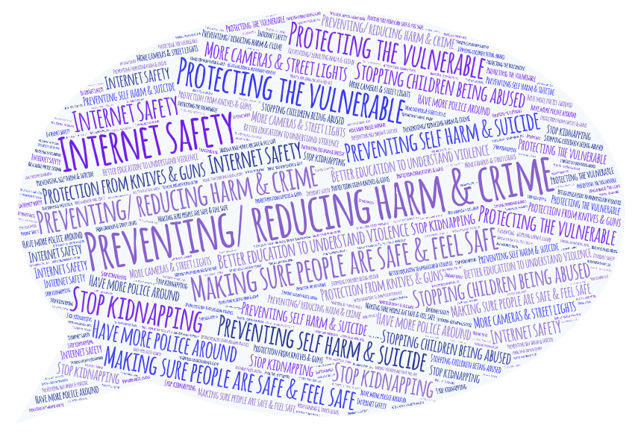

The top answers
1 | Preventing/ reducing harm & crime from happening to others
2 | protecting the vulnerable
3 | Making sure people are safe and feel safe
4 | Prevent self-harm & suicide
5 | Internet safety
6 | Stopping children being abused
7 | Better education in schools & the community to understand causes of violence
8 | Stop kidnapping
9 | Have more police around
10 | Protection from knives & guns
11 | having more cameras & street lights

‘Preventing/ reducing harm & crime from happening to others’ was almost twice as popular as the next top answer

Key comments from children & young people

‘Harm can damage a person not just physically but also mentally and that is wrong and can be long lasting’

‘If police are more focussed on the issue of mental health they can help kids and young people who may harm themselves or others.’

‘In some instances it is not possible to prevent the harm and therefore the most important thing is for the police to support the victims of harm’

‘Although it can help us grow, we shouldn't have to experience harm in order to grow up’

'Young people need to be educated to understand risks of getting involved with gangs and crime from an
early age '

‘Prevention of harm is the basic role of the police- I don’t think it needs its own title as it should over arch everything’

‘To me, prevention of harm means having safeguards in place to increase safety but also encourage an open line of communication between children and younger people and the police’

‘The see the signs campaign & Fearless.org good prevention tools that should be rolled out in all schools’

‘It sounds like the police are more interested in helping people to avoid harm, rather than stopping the causes’

‘This should be in my opinion more targeted at likely victims, teaching methods of de-escalation and evasion from possible threats’

‘I think the police need to Inform and educate others about all the risks and dangers, and reassure us that the police are here to help’

What do children & young people want the police to do or not do in relation to this priority area?
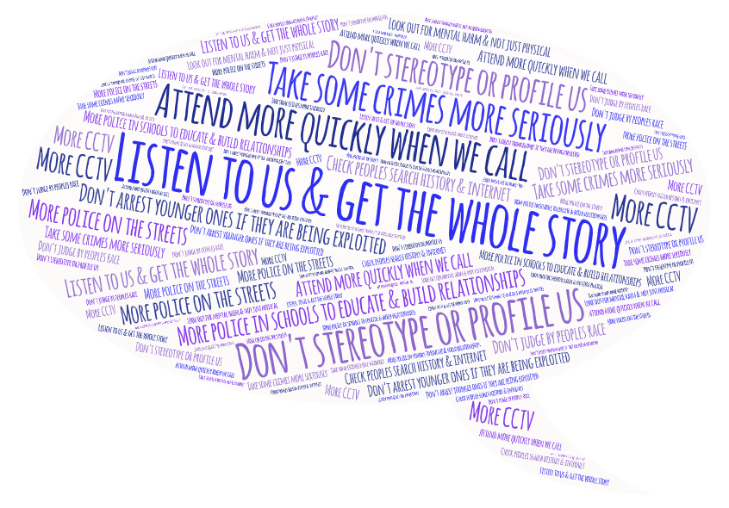

The top answers
1 | Listen to children and young people and get the whole story
2 | Not presume we are in the wrong or stereotype and profile us
3 | Attend more quickly if we call the police
4 | Take Racism, bullying, hate crime, sexual assault and online bullying more seriously
5 | More police to visit schools to educate us about staying safe & we can learn to trust them (Careers days, bike postcode marking in schools)
6 | The police should walk around the community more so young people get to know them, trust them and can report crimes
7 | Don’t arrest the vulnerable young people who are exploited, but the 'olders' who are exploiting them
8 | Check peoples search engines & internet
9 | Look out for mental harm as well as physical harm
10 | More cctv
11 | Don’t not judge people by their race

Key comments from children & young people

‘The police need to be involved in schools & do fun workshops like crime scene investigation or quizzes so kids get to know them, have fun and learn stuff’

‘Make more telephone boxes available so people can communicate if they run out of battery and so they can call for help’

‘I think it would be really good if they could have sessions with local schools that the students can book independently on the police website and ask questions if they didn’t want go to though a member of school staff. Something like ‘have a chat with your local PCSO/Police officer’, but aimed at the younger generation’

‘People should know more about the work the police do as there is a lot of negative stereotype of police. They need to make more of an effort to show what they do and how they care’

‘We need more of an emotional connection to get to know the police in our local area- not just Facebook’

‘Easily accessible information, that can be obtained through social media, such as non skippable adds on snapchat with quick 5 second bits of advice. If people have to read something or do their own research it will be lost on people of my generation’

‘For more personal issues I think improving communication can be a big thing, currently for students if they have a concern which they don’t want to go to a school or GP about it can be very hard as there is nowhere else to go’

‘More training courses for Police officers to attend about issues like; domestic violence, warning signs, self-harm, mental health etc’

‘I believe that it prevention of harm is a very important topic, especially in the parts of Essex closer to London, this is because of the rise in knife crime and other violent crime in the higher density area will spread through to Essex putting people, especially younger people at risk of harm’

‘prevention of harm and keeping children safe is much wider than the police remit and workshops like personal safety, community safety & see the signs should be embedded in the curriculum’

‘Better use of resources to prevent rather than punish’

‘Would like police to focus on proactive youth work and consider reasons behind youth crime. Also to go into schools to talk about crime and safety’

‘Kids are scared of the police’

‘A smile or friendly hello sometimes would make some more willing to approach the police for help’

‘Try to work with neighbouring forces because very common for people to live in one area yet travel to another for school or work, so make the advice accessible for all’

Do children & young people think that 'Police custody' is a good
priority area?


77% of children & young people agreed that
‘police custody’ is a good priority

Please note that the answers from children & young people to this priority area were quite mixed as the majority of children & young people felt ‘police custody’ had quite negative connotations that confused them as to why it would be the heading of a priority area for the police.

Why is ‘police custody’ a good/ not so good priority to have?

The top answers
1 | Police stations are made for adults and might be scary for children
2 | Custody is what the police do when you are arrested
3 | The name is confusing and I don’t understand why something so negative is a priority
4 | If someone has done something wrong, then they should be punished for it
5 | Punishment isn’t always the right thing, sometimes education is needed
6 | If you have a suspect in custody they have no chance of committing another crime
7 | Don't lock us up and take away our freedoms when we have done nothing wrong
8 | Should be a better use of sectioning, improved mental health/crisis general resources

What does ‘police custody’ mean to children & young people?
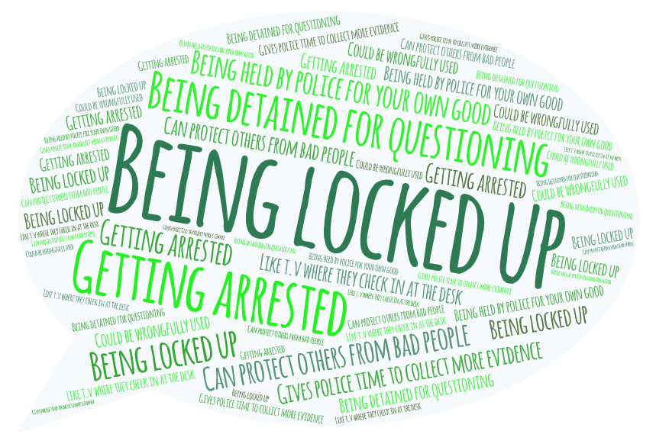

The top answers
1 | Being locked up in prison or a cell
2 | Getting arrested
3 | Being detained somewhere for questioning like a police car until they are arrested or released
4 | Being held by the police for own good or done something wrong/ cooling off
5 | Can protect others from bad people for a time
6 | Gives police time to collect more evidence
7 | What we see on TV when they get checked in at the desk
8 | Could be wrongfully used

‘Being locked up’ was over 4x as popular as the next top answer

Key comments from children & young people

‘Although it is important that police can take people into custody, I don’t think it is important because the police should be focussing their resources on other priorities, rather than arresting people’

‘When accused individuals are not in custody it can cause fear for their victims’

‘Being in custody often helps people calm down and helps the situation’

‘Whilst I have never been in police custody so I don’t know what its fully like, I do believe that this is an important part of the strategy. Whilst they are in this scenario it is likely to be one of the most isolated times they have had/experienced and this time could massively change their perception of the police’

‘Custody means locking young people up - why would you want that set as a priority?’

‘I have been arrested and been in the cells. The first time they were nice and some officers checked to make sure I was ok. They let my mum sit with me and she was able to ask questions about what was happening. The second time I did not see my mum and I felt worse because I didn’t know what was going on.’

‘Custody is no deterrent; it is horrible in custody, but it just makes you hate the police more’

What do children & young people want the police to do or not do in relation to this priority area?

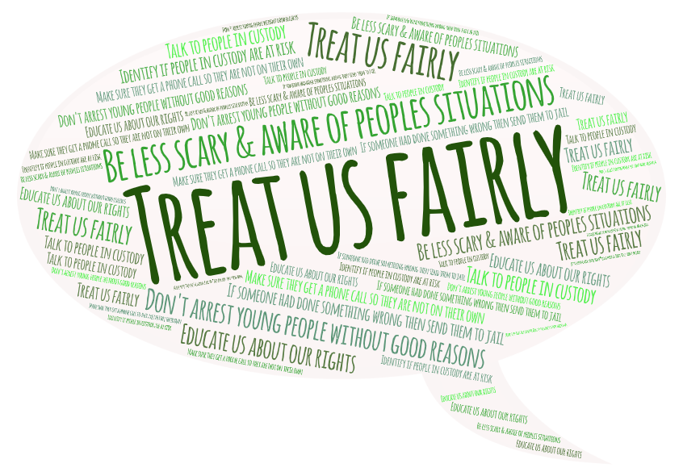

The top answers
1 | Make sure children and young people are treated fairly
2 | The police could be less scary when it comes to taking people into custody & be mindful of people’s situations, their mental state and their age
3 | Don’t arrest young people without good reasons
4 | If someone has done something wrong, they should go to jail
5 | Make sure they get a phone call so they are not on their own
6 | I don’t know anything about police custody
7 | Educate us about rights
8 | Talk to people in custody
9 | Identify if people in custody are at risk

Key comments from children & young people

‘They should be held until trial and then supported to engage in their community in a more positive way with youth friendly workers who have special training’

‘It is important for the police to say they are sorry and to own up to mistakes if you are falsely arrested’

‘I think the police need to look at the stem of the issue and help to try and make an action plan going forward in the early days of offending before going forward onto more serious crimes and having to spend time in jail’

‘It’s scary they are children; police need to look at the whole picture of the young person’s life’

‘Police could involve youth workers when young people are detained in custody and may be feeling scared for their future’

‘Leave us young people alone and stop stereotyping us just because we wear hoodies’

‘Maybe the police should call this area ‘improving custody ‘rather than just ‘custody’ as it just sounds like they want to lock more of us up’

Do children & young people think that 'Reducing
youth offending & criminalisation' is a good priority area?

97% of children & young people agreed that
‘reducing youth offending & criminalisation’
is a good priority

Why is ‘reducing re-offending & criminalisation’ a good/ not so good priority to have?

The most popular answers to this question
1 | Because the police could help us if we are forced to take the blame for something we didn’t do
2 | The police might be able to stop us getting bullied
3 | It could help young people from being exploited or groomed as young people are easily manipulated
4 | Teaching young kids that actions have consequences – it should be more about rehabilitation than labelling as criminal, everyone deserves a second chance
5 | It might stop young people becoming criminals and go back into society as non-offenders
6 | It will help keep communities safe
7 | If young people have done something really bad then going to prison might help
8 | Young people get scared in jail. They need their families
Key comments from children & young people

‘The priority could be called ‘preventing crime & criminal behaviour in young people as this sounds better’

‘It's important young people learn about consequences of actions as they can mess up lives forever’

‘If you target children when they are young, then it could prevent problems later on & reduce re-offending’

‘We should be supported to find a life away from crime to reduce the negative impact on our future’

‘This needs to be looked into but I feel that my words/feelings/responses will not change anything’

‘Youth offending gives all young people a bad reputation and I don’t think this is fair’

‘Teenagers make stupid mistakes & so minor offences shouldn’t criminalise us forever’

What does ‘reducing youth offending & criminalisation’ mean to children & young people?
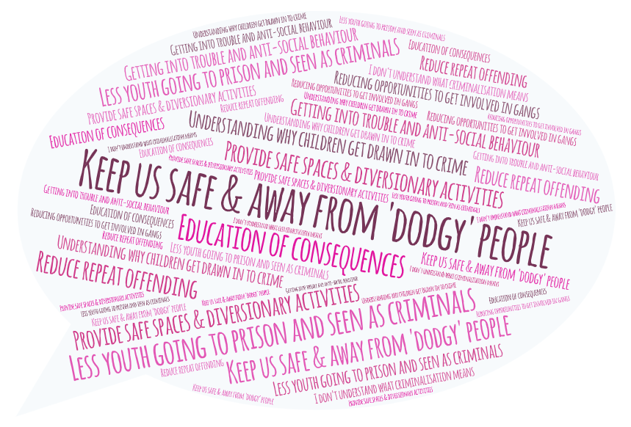

The top answers
1 | Keeping children safe so they don’t get involved with 'dodgy' people
2 | Less youth going to prison or seen as criminals
3 | Provide safe spaces and diversionary activities that draw our attention away from crime and negative peers
4 | understanding why some children and young people might get into trouble rather than presuming they are criminals
5 | Its young people getting in trouble & anti-social behaviour
6 | Educating of consequences of actions
7 | To reduce the opportunities of young people to become involved in gangs and exploitation
8 | This means to us that stop repeat offending, stopping behaviour before they hit 18 when the consequences are much higher
9 | I don’t understand what criminalisation means

The top 2 answers were 2x as popular as other answers

What young people want the police to do or not do in relation to this priority area?
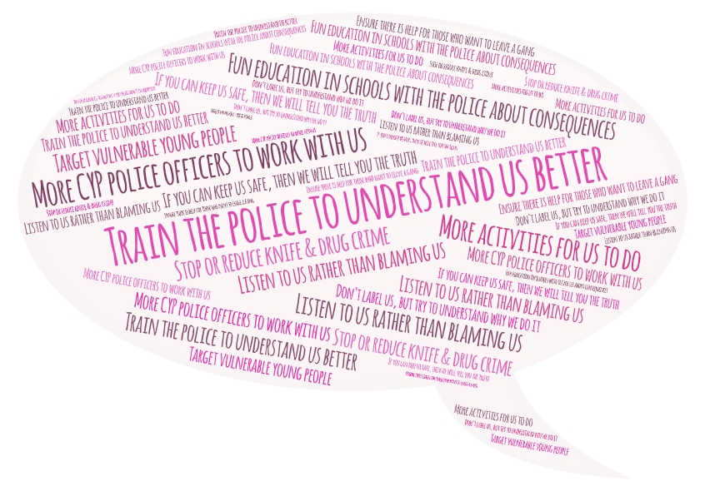

The top answers
1 | Train the police so they can understand children and young people better & our behaviours
2 | Education in schools with the police involved in fun & engaging ways to inform young people about consequences of their actions
3 | Listen to children and young people rather than blaming them
4 | Have more children & young people’s police officers to work with young people
5 | If you can keep us safe then we will tell you the truth
6 | Don’t label us straight away, try to understand why we might be doing it
7 | Put activities on for the young people to do instead
8 | Stop or reduce knife & drug crime
9 | Target vulnerable young people
10 | Ensure there is help for young people who want to leave gangs

Key comments from children & young people

‘Informing & educating young people from deprived backgrounds should be a primary concern, as they would be most likely to consume drugs without knowing the consequences of their actions’

‘Provide other options to crime to get money - skills training apprenticeships ‘

‘Long term mentoring YP need same consistent positive role over a year not just 6 sessions’

‘Working with under-privileged communities which are more likely to be against the police to challenge their perception’

‘Have more interaction with schools. I am now in year 12 and I think I have only seen the police here twice in my whole 5 years of secondary school’

‘Police could work with local 3rd sector providers to open up youth clubs so we have somewhere to go and someone to talk to. Staff can also put early interventions in place to help reduce crime over the long term’

‘Change young people’s attitude to criminal offences... some people might think screw it I’m only 16 it’s not a big deal’

‘I understand that there are currently schemes in place to advise us of the consequences of crime however, I believe that it should be a lot “scarier” because currently when presenting in schools it feels like a chore and did not make me care about consequences’

‘Reducing youth offending & criminalization is important because if we are criminalized when we are young then we could be stereotyped and discriminated against unfairly when we are an adult’

‘Provide opportunities for young people in prison to have a chance to change their life so they don’t go back to old habits’

‘YP are often struggling enough from broken families and gangs are a way out and a place to belong’

‘Youth centres and affordable activities are really important’

Do children & young people think that 'Protecting the rights of
children & young people' is a good priority area?

97% of children & young people agreed that
‘protecting the rights of children & young people’
is a good priority

Please note that although the majority of young people agreed that this should be a high priority, they also stated that they felt this was the job of the police anyway and should under pin everything.

Why did children & young people think that this was or was not a good priority for the police to have?

The top answers
1 | Everyone should know their rights and have them protected
2 | I’m unsure as to whether this should be a priority as I think this should just be standard
3 | Because adults should care that we are safe and treated fairly
4 | We need to be listened to just as much as adults
5 | Because it’s the right thing to do
6 | We are more vulnerable because of our age
7 | Children sometimes retract their stories of abuse because they are scared of family. They need support to get help

What does ‘protecting the rights of children & young people’ mean to children & young people?
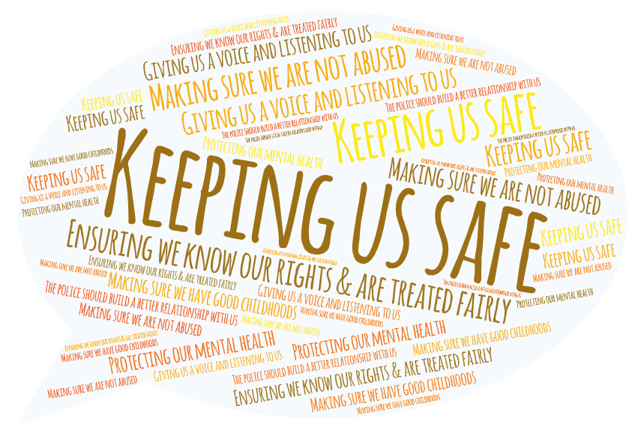

The top answers
1 | Keeping children and young people safe
2 | Ensuring young people know what their rights are & are treated fairly
3 | Making sure children and young people are not abused
4 | Giving young people a voice and listening to them
5 | Protecting our mental health
6 | Making sure we have a good childhoods without becoming victims
7 | It means that the police should build a better relationship with the younger generation

What do young people want the police to do or not do in relation to this priority area?
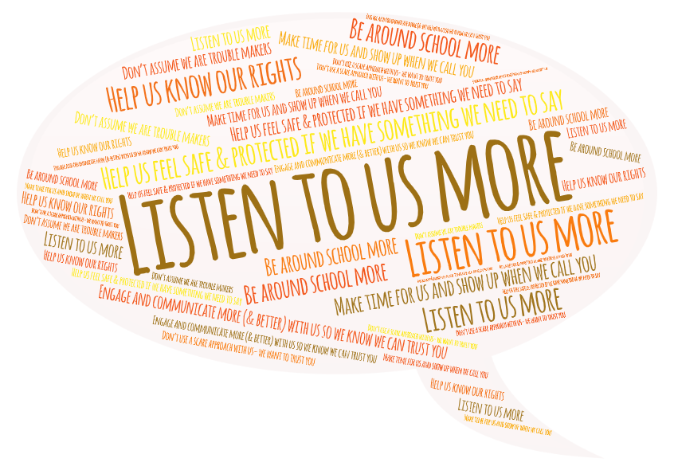

The top answers
1 | Listen to us more
2 | Help us feel safe & protected if we have something we need to say
3 | Be around school more & do assemblies & workshops for young people
4 | Engage & communicate more (& better) with us so we know we can trust you
5 | Make time for us and show up when we call you
6 | Help us know our rights
7 | Don’t assume we are trouble makers
8 | Don’t use a scare approach with us- we want to trust you

Listen to us’ was over 2x as popular as the next top answer

key comments from children & young people

‘The Southend CYP have rolled out Trauma Informed Policing and how to work with vulnerable YP. I would love to see this delivered across all Essex Policing Teams’

‘Make sure the children are in school, protect children by putting cameras everywhere so you see if someone tries to take children’

‘Police should have more powers to protect children in cases of child protection, even above social care as there are incidences where children suffer serious harm because social care will not allow police to remove children from the situation’

‘The police shouldn’t do this directly as Social services should. It’s not the role of police’

‘The police could do more to communicate our rights so that if we are stopped and searched or giving a voluntary interview then we know what they are’

‘When it comes to kids hanging out and a moany old person says we are noisy its always the grown up they talk to first and believed- we are all judged all the time we have a right to be there just as much as they do’

‘We need to feel safe in the hands of police even if they are the suspect or the victim’

‘Remove initial prejudice against the voice of the young person as our voice is just as valid’

‘we also have political opinions so listen to us & teach us our rights’

‘kids would feel more safe if they had a better relationship with the police’

‘Young people become de-sensitised & overwhelmed by the amount of crime and awful stories that you see and hear on social media which can impact on their views of the police & statutory services’
Do children & young people think that 'Improving the
relationship between police officers & children & young people'
is a good priority area?

89% of children & young people agreed that
‘Improving the relationship between police
officers & children & young people’
is a good priority

Please note that the 6% who said that they were ‘unsure’, said that they could not imagine a good relationship with the police and wouldn’t want to be seen near the police

Why did children & young people think that this was or was not a good priority for the police to have?

The top answers
1 | If we had a better relationship with the police, we would have someone to go to when bad things happen
2 | Sometimes we are rude to the police because we are afraid of them or don’t understand how they can help
3 | If we trusted the police then they could do their job better and people would be safer
4 | The police are there to protect & help us and so we should get along

What does ‘Improving the relationship between police officers & children & young people’ mean to children & young people?
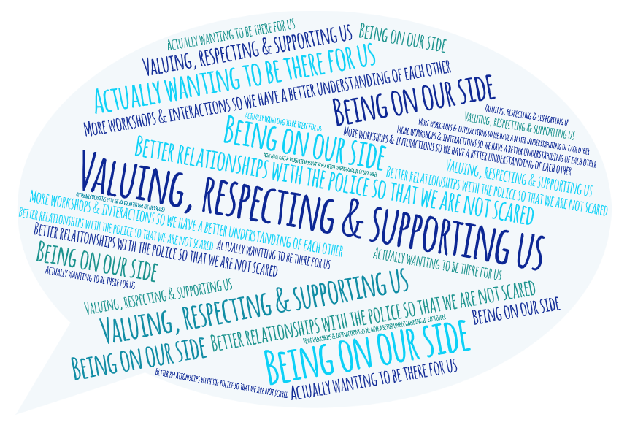

The top answers
1 | Valuing, respecting & supporting us, rather than presuming we are bad
2 | Being on our side
3 | Better relationships with the police so that we know we can approach them & not be scared
4 | More workshops & interactions with the police so we have a better understanding of each other
5 | Building trust & making sure we are safe
6 | Actually wanting to be there for us

The top answer was over 2x as popular as the next answer

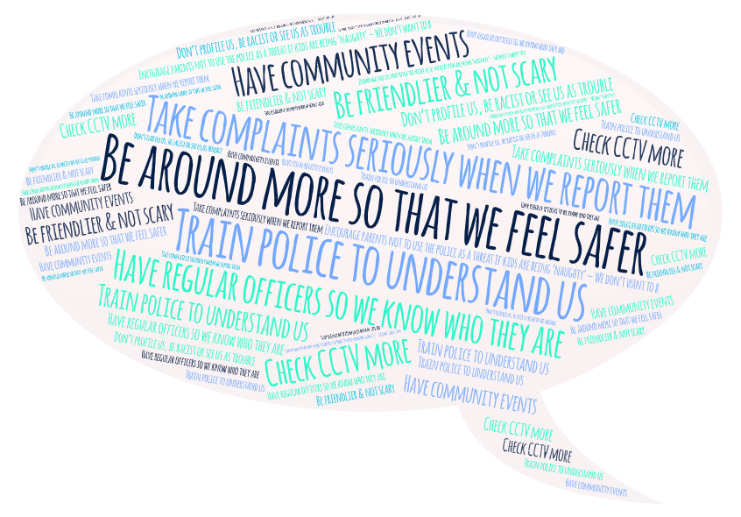
What do children & young people want the police to do or not do in relation to this priority area?

The top answers
1 | Be around more in schools & community so that we feel safer & build relationships
2 | Train new police to understand us
3 | Take complaints seriously when we report them
4 | Have regular officers so we know who they are
5 | Have community events
6 | Be friendlier & not scary or intimidating
7 | Encourage parents not to use the police as a threat if kids are being ‘naughty’ – We don’t want to be scared of the police
8 | Don’t profile us, be racist or see us as trouble
9 | Check CCTV more

‘Be around more in schools & communities’ was over 2x as popular as the next answer

key comments from children & young people

‘There will always be difficulty improving relationships between us and the police, until the police are able to have enough officers where they can regularly patrol areas, this would allow people to get to know officers on a more personal level’

‘The police need to work on their appearance and approach as many young people see them as a negative authoritarian figure’
o in relation to this priority area?
‘A Police Officer should be able to control their attitude and behaviour even if a young person’s attitude or behaviour is a negative one’

‘We need more community policing teams to build relationships with schools and youth providers. They could run a football tournaments or fun things to show that they are there to protect and serve the community not just enforce the law’

‘We want the police to we working together with us, not just arresting; being friends not enemies’

‘It’s important for us to know that the police are on our side no matter our background, sexual preference or skin colour’

‘We have concerns about the murder of Sarah Everard and whether this could happen again’

‘The police should try to build a more personal connection with people, it would be great to be in an area where I can walk down past a group of police officers and then I would be able to know all of their names even if I hadn’t been arrested/detained by them’

‘Run events like allowing the children to look in the police cars, open days, school assemblies, personal safety in schools, cuppa with a Copper etc in a fun way so we get to like the police’

‘In films and music it is 'cool' to dislike the police, but If I was in trouble and needed the police then I would want to be able to trust and talk to them’

‘I want the police to talk to me when I say hello- Not all police encounters should be business related’

‘We don’t understand what the police do’

Do children & young people think that 'Children in care'
I is a good priority area?

76% of children & young people agreed that
‘Children in care’ is a good priority

Please note that a lot of young people did not understand why it was just about Children in care. This is reflected in their votes around if this is a good priority area. The term needed explaining by the youth leaders before young people engaged much in the conversation. They ask- ‘Do you think this is broad enough? Young carers, child protection, could this be called vulnerable young people?’

Why did young people say that this was or was not a good priority for the police to have?

The top answers
1 | We don’t understand what the term means or why it is a priority heading
2 | Its good because young people in care are vulnerable and are more likely to get in trouble
3 | Its good because young people in care have usually had something really bad happen to them and don’t have family to keep an eye on them and care about them
4 | If a child has nowhere else to go it’s vital they have the police for reassurance

What does ‘children in care’ mean to children & young people?
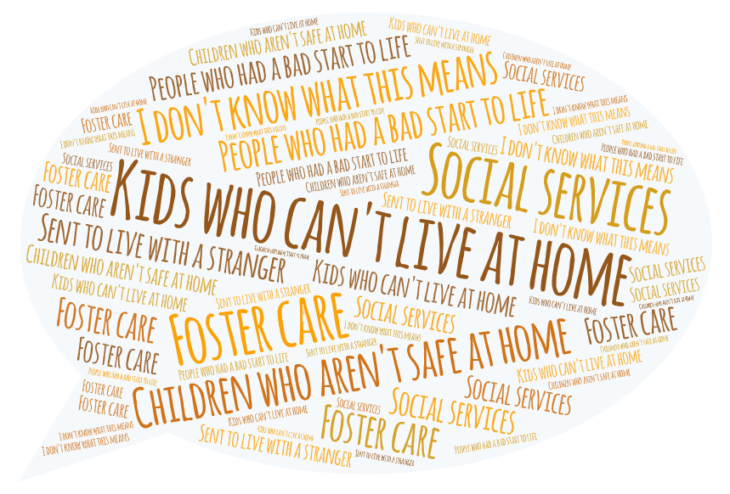

The top answers
1 | Kids who can’t live at home
2 | Children who need protecting because they are not safe at home
3 | I don’t know what this means
4 | Foster care
5 | Social services
6 | People who have had a bad start to life
7 | Being removed from your home to live with a stranger

‘Kids who can’t live at home’ was 4x as popular as the next answer

What do children & young people want the police to do or not do in relation to this priority area?
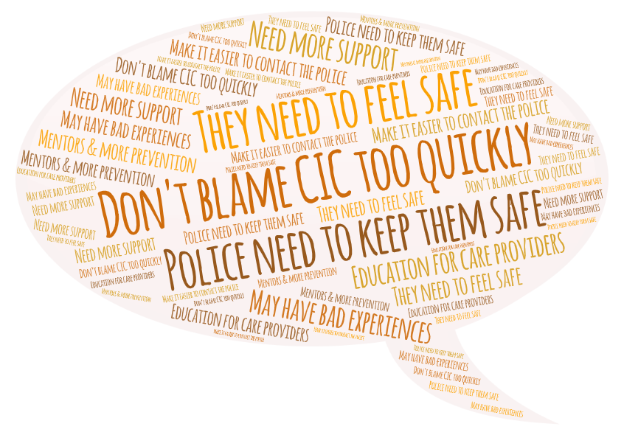

The top answers
1 | Don’t blame CIC too quickly as they might be being exploited
2 | They need to feel safe & know they are important
3 | Police need to keep them safe & check up on them because they are more vulnerable to crime & exploitation
4 | They may have had bad experiences with the police or other professionals before so be nicer
5 | CIC need support from as many people as possible because they don’t have their families
6 | Make it easier for young people to contact the police
7 | More education with carer providers… do the police really need to be called
8 | Mentors for young people & prioritising prevention

The top answer was
3x as popular as the next answer

key comments from children & young people about this priority

‘CIC have a massively different background & need a different approach ‘

‘Children in care is a very important priority, they are vulnerable to anger issues and rebelling because of their past trauma. They also don’t have guidance after the age of 18 where they are no longer in foster care’

‘The police should be prioritising prevention, the more they prevent and educate the less crimes are committed’

‘It was the Police who made sure I had a bad start’

‘Go and check up on the children who are known to services. If they move to a different area the police should check up on them when they move in to make sure they are okay’

‘Listen to those who are in need and vulnerable…. Really listen to them’

‘Support children in care if they are scared. It’s important that the police understand them’

‘Young people in care get judged too quickly & they are more likely to be exploited’

‘It’s important because young people in care can feel unwanted’

‘I am glad the police acted when I needed protection’

‘There are lots of stereotypes around children in care, police need to know that they’re just normal kids who need extra support ‘

‘If children in care make a mistake it ends in criminal activity whereas other young people’s behaviour gets dealt with in the family home… example is a lot of care homes ring the police to deal with things’

‘Leave us alone, we don't want to be different because we are in care’

‘Children who can’t live with their mummies are still important and they need to be taken care of by someone else’

What do children & young people think is the most important thing in the strategy that the police
need to focus on?

The top answers
1 | Building positive relationships with young people
2 | Reducing criminalisation and offending
3 | Preventing harm
4 | Keeping us safe
5 | Listening to us
6 | Protecting children in care
7 | Protecting our rights & reducing reoffending
8 | More safe activities for us to do

Is there anything children & young people think has been forgotten about in this strategy or they
want to say to the police?

‘There are so many barriers between young people and working with the police- they refuse to report incidents to police when they have been a victim of crime, they are scared to report crime for fear of being called a grass. they don’t want to talk to police or give info as they could end up getting nicked for swearing (breach of peace, public disorder) as they are upset angry hurt at what has happened police don’t listen or understand, police are heavy handed and aggressive etc’

‘Police should be more approachable. The police have become the villains when they should be the heroes!’

‘We never hear in the media about the good things that the police do’

‘Young people feel that they are being targeted with regards to electric scooters’

‘The police in Southend have made massive steps towards training their police to work with young people, they have supported the YMCA to open a youth club and obtain funding. We would like to see Youth Initiative Action Groups working across the whole of Essex’

‘Suicide, needs to be in the strategy as a lot of people get bullied and decide to take their lives’

‘Addressing the gap in black people being disproportionately prosecuted needs to be looked at’

‘Children’s mental health – early help means that young people are less likely to commit crimes or harm others’

‘Focusing on communities – one community can have an issue with a certain crime that can be focused on’

‘The police need to break down the barrier between the public and the police in ways that go beyond running information sessions. They need to learn how to get through to young people, build relationships and deliver their message in relevant ways’

One youth leader shared that a participant came to them after the session and asked to include that there should be more focus on hate crimes, sexual assault, rape and paedophilia among young people. The young person also stated that the discrimination and ignorance shown by both the public and the police towards the LGBTQIA+ youth community has a real impact on their likelihood of mental health, criminal behaviour and self-harm’

‘I would like more police presence on the streets rather than CCTV because if police where present then they would intervene and help when I am being bullied. When people see it on CCTV then they just see a group of boys fighting and do nothing about it’

-Rachel Brett (ECVYS CEO)

